Lab - Isolate Compromised Host Using 5-Tuple
Additional Note: Yellow highlighted text indicates all of my answers.
(672021159)

Objectives
In this lab, you will review logs that were gathered during the exploitation of a documented vulnerability to determine the compromised hosts and file.
Part 1: Review Alerts in Sguil
Part 2: Pivot to Wireshark
Part 3: Pivot to Kibana

Background / Scenario
The 5-tuple is used by IT administrators to identify requirements for creating an operational and secure network environment. The components of the 5-tuple include a source IP address and port number, destination IP address and port number, and the protocol in use in the data payload. This is the protocol field of the IP packet header.
In this lab, you will also review the logs to identify the compromised hosts and the content of the compromised file.

Required Resources
- Security Onion virtual machine
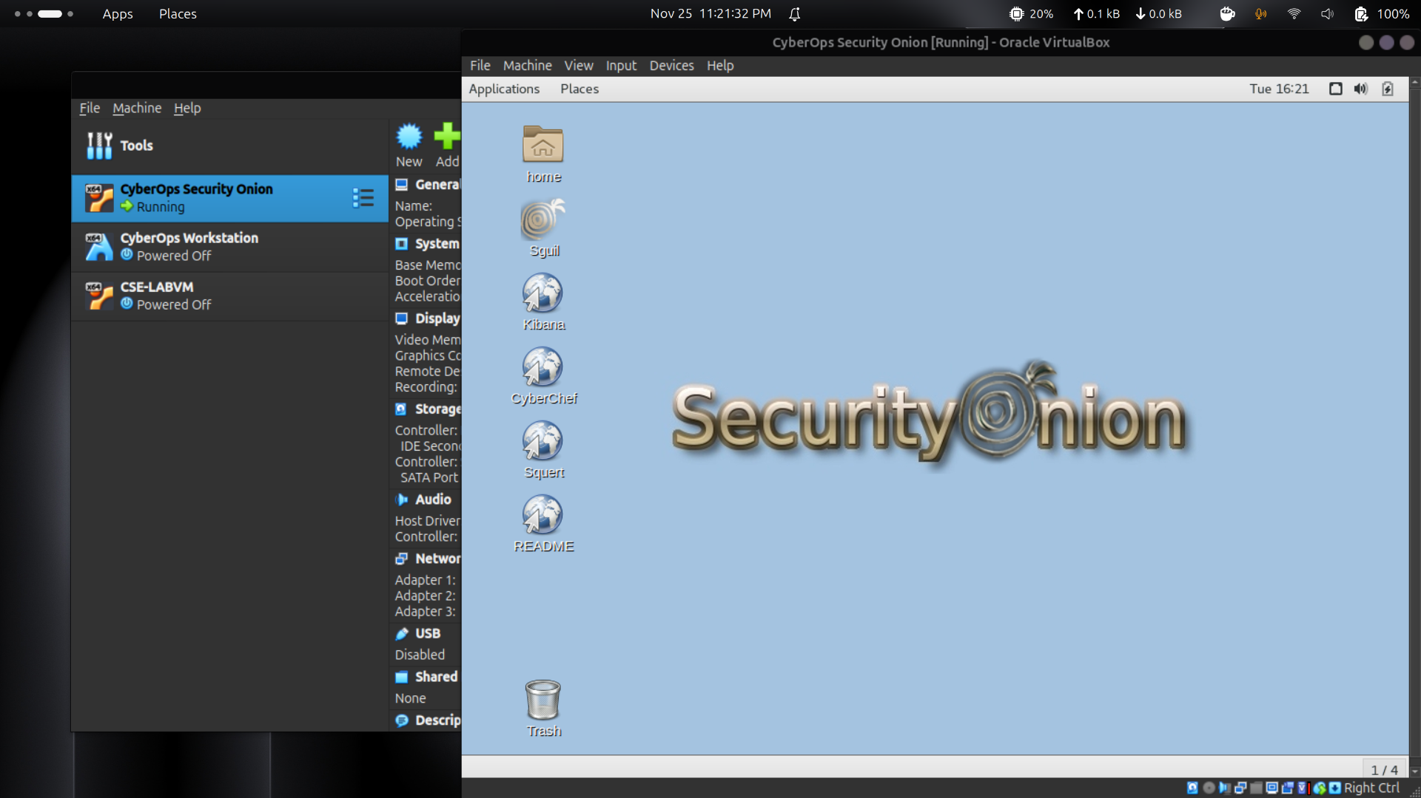

Instructions
After the attack, the users no longer have access to the file named confidential.txt. Now you will review the logs to determine how the file was compromised.
Note: If this was a production network, it is recommended that analyst and root users change their passwords and comply with the current security policy.

Review Aerts in Sguil
    - Launch the Security Onion VM and log in. Log in with the user analyst and password cyberops
    - Open Sguil and log in. Click Select All to select the interfaces and then Start SGUIL.
    - Review the events listed in the Event Message column. One of these messages is GPL ATTACK_RESPONSE id check returned root. This message indicates that root access may have been gained during an attack. The host at 209.165.200.235 returned root access to 209.165.201.17. The alert ID 5.1 is used as an example in this lab.
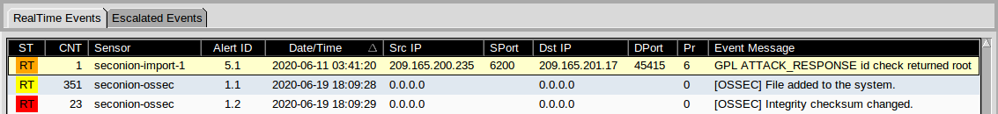
    - Select the Show Packet Data and Show Rule checkboxes to view each alert in more detail.
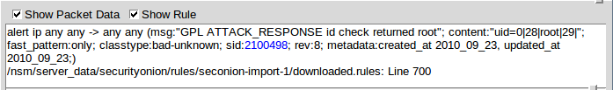
    - Right-click the alert ID 5.1 and select Transcript.
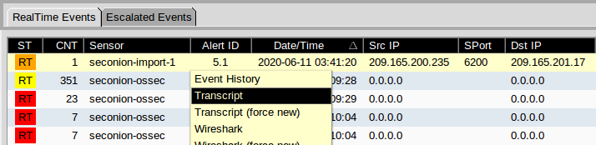
    - Review the transcripts for the alert. The transcript displays the transactions between the threat actor source (SRC) and the target (DST) during the attack. The threat actor is executing Linux commands on the target.
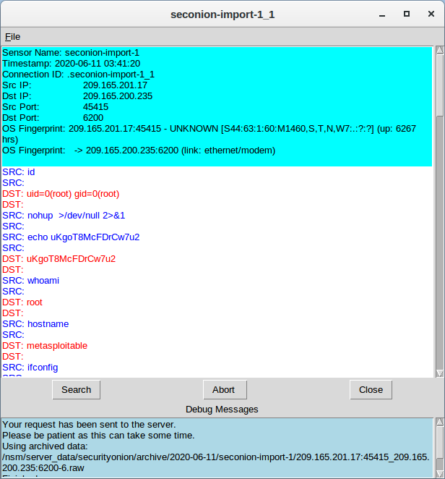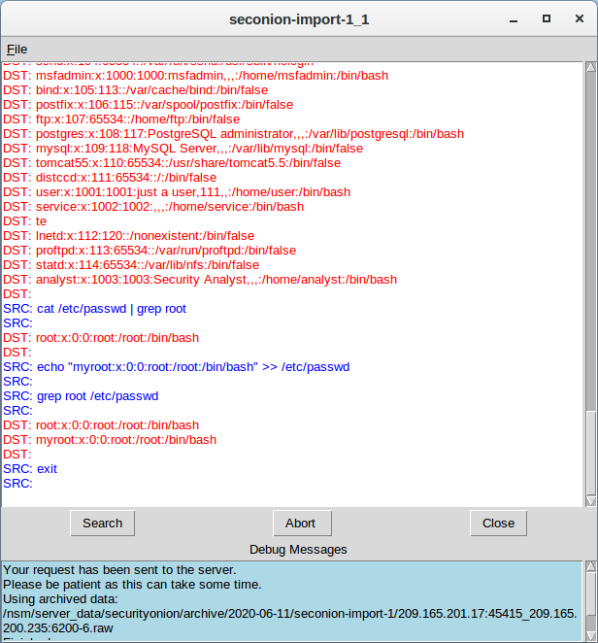

Question:
What kind of transactions occurred between the client and the server in this attack?
Penyerang dari IP 209.165.201.17 berhasil mendapatkan akses root pada 209.165.200.235, lalu menjalankan perintah Linux seperti menjelajahi sistem file, menyalin file shadow, serta mengubah isi /etc/shadow dan /etc/passwd.

Pivot to Wireshark
    - Select the alert that provided you with the transcript from the previous step. Right-click the alert ID 5.1 and select Wireshark. The Wireshark main window displays three views of a packet.
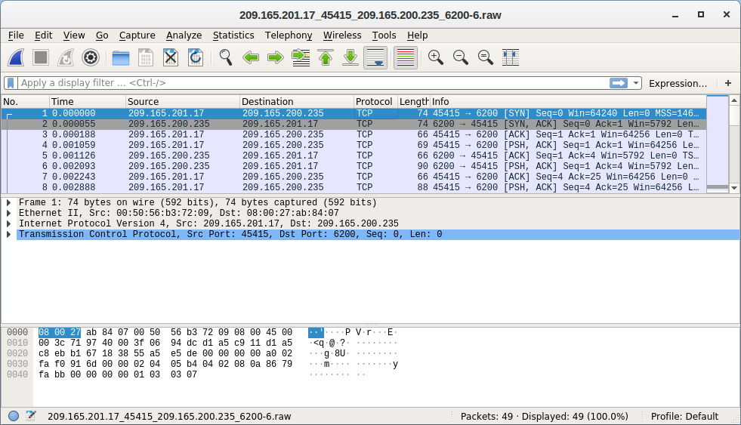
    - To view all packets that are assembled in a TCP conversation, right-click any packet and select Follow > TCP Stream.
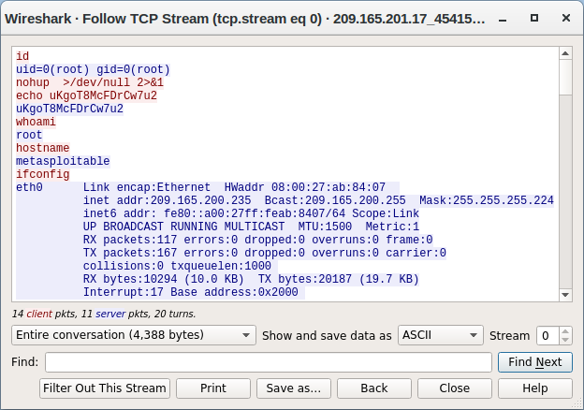

Question:
What did you observe? What do the text colors red and blue indicate?
Tampilan TCP stream menunjukkan komunikasi antara penyerang dan target. Teks merah menggambarkan perintah dari penyerang, sedangkan teks biru adalah respons dari sistem target. Hostname target adalah metasploitable dengan IP 209.165.200.235, dan isi informasinya sama seperti transcript sebelumnya.
The attacker issues the whoami command on the target. What does this show about the attacker role on the target computer?
Perintah tersebut membuktikan bahwa penyerang sudah memiliki hak akses penuh sebagai root di mesin target.
Scroll through the TCP stream. What kind of data has the threat actor been reading?
Penyerang terlihat mengakses data akun pengguna, seperti informasi user pada sistem.
    - Exit the TCP stream window. Close Wireshark when you are done reviewing the information provided.

Pivot to Kibana
    - Return to Sguil. Right-click either the source or destination IP for the alert ID 5.1 and select Kibana IP Lookup > SrcIP. Enter username analyst and password cyberops if prompted by Kibana.
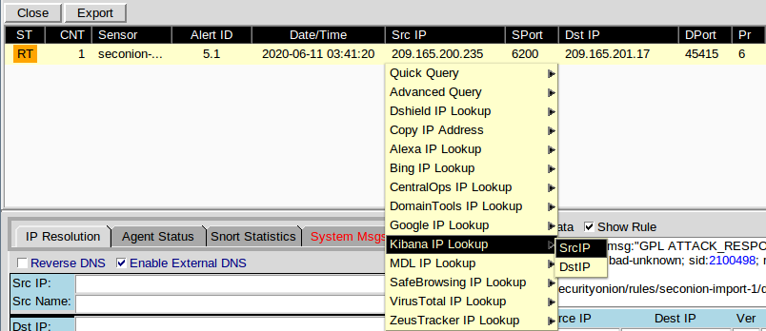
Note: If you received the message "Your connection is not private", click ADVANCED > Proceed to localhost (unsafe) to continue.
    - If the time range is the last 24 hours, change it to June 2020 so June 11 is included in the time range. Use the Absolute tab to change the time range.
    - In the displayed results, there is a list of different data types. You were told that the file confidential.txt is no longer accessible. In the Sensors - Sensors and Services (Pie Chart), ftp and ftp-data are present in the list, as shown in the figure. We will determine if FTP was used to steal the file.
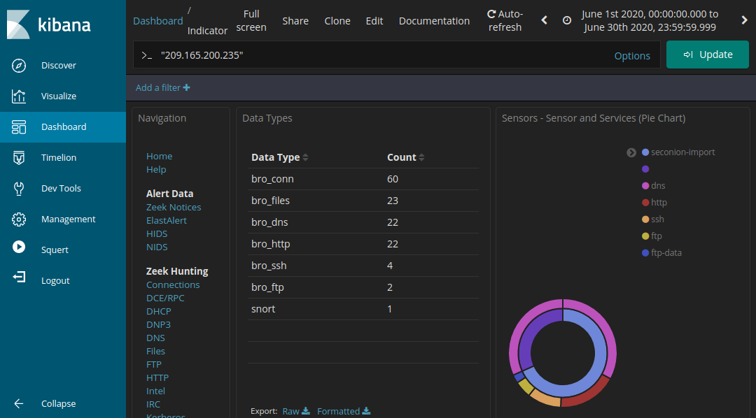
    - Let's filter for bro_ftp. Hover over the empty space next to the count of bro_ftp data types. Select + to filter for only FTP related traffic as shown in the figure.
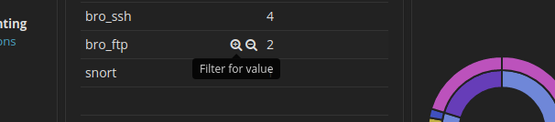
    - Scroll down to the All Logs section. There are two entries listed.

Questions:
What are the source and destination IP addresses and port numbers for the FTP traffic?
Sumber koneksi adalah 192.168.0.11:52776, dan tujuannya 209.165.200.235:21 (port FTP).
    - Expand and review both log entries. In one of these entries, the ftp_argument has an entry of ftp://209.165.200.235/./confidential.txt. Also review the message in the log entry to learn more about this event.
    - Within the same log entry, scroll up back to the alert _id field and click the link.
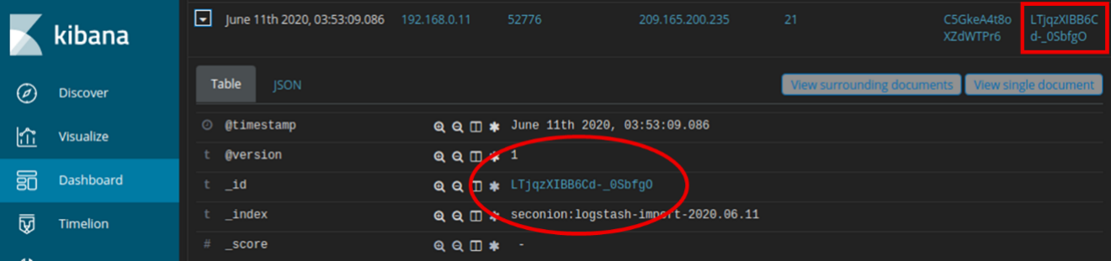
    - Review the transcript for the transactions between the attacker and the target. If desired, you can download the pcap and review the traffic using Wireshark.

Question:
What are the user credentials to access the FTP site?
Akses FTP menggunakan username analyst dan password cyberops.
    - Now that you have verified that the attacker has used FTP to copy the content of the file confidential.txt and then deleted it from the target. So what is the content of the file? Remember one of the services listed in the pie chart is ftp_data.
    - Navigate to the top of the dashboard. Select Files under the Zeek Hunting heading in the left panel, as shown in the figure. This will allow you to review the types of the files that were logged.
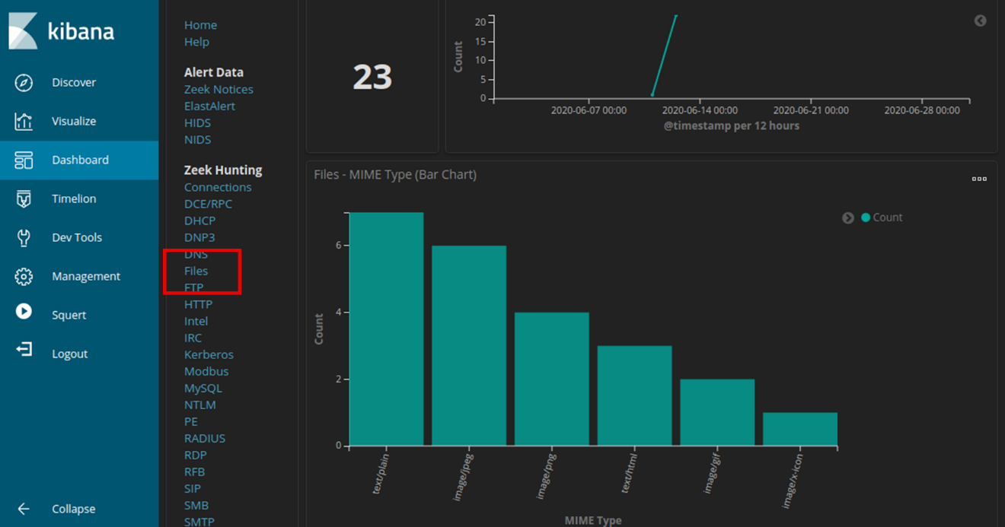

Questions:
What are the different types of files? Look at the MIME Type section of the screen.
Jenis file yang tercatat adalah teks dan beberapa jenis file gambar.
Scroll to the Files - Source heading. What are the file sources listed?
File-file tersebut berasal dari dua sumber: HTTP dan FTP.
    - Filter for FTP_DATA by hovering over the empty space next to the Count for FTP_DATA and click +.
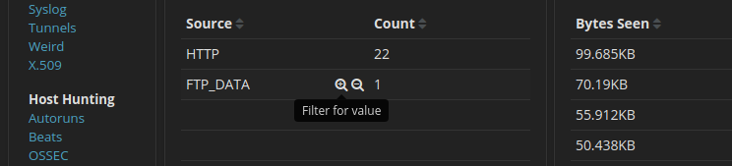
    - Scroll down to review the filtered results.

Question:
What is the MIME type, source and destination IP address associated with the transfer of the FTP data? When did this transfer occur?
File yang ditransfer adalah teks biasa, dikirim dari 192.168.0.11 ke 209.165.200.235, dan proses transfer terjadi pada 11 Juni 2020 pukul 03:53.
    - In the File logs, expand the entry associated with FTP data. Click the link associated with alert _id.

Question:
What is the text content of the file that was transferred using FTP?
Isi filenya:
CONFIDENTIAL DOCUMENT
DO NOT SHARE
This document contains information about the last security breach.
With all the information has gathered so far, what is your recommendation for stopping further unauthorized access?
At a minimum, the password for the username analyst should be changed throughout the network (209.165.200.235 and 192.168.0.11)
End of document

